**Test Your Understanding**

**Question**: Journalize and post the closing entries for June.

**Question Input:**

|  |  |  |  |  |  |  |  |
| --- | --- | --- | --- | --- | --- | --- | --- |
| **Trial Balance** | | | | | | | |
| **June 30, 2019** | | | | | | | |
|  | **Chart of Accounts** | | | | | **Debit** | **Credit** |
|  | Cash |  |  |  |  | 8,635 |  |
|  | Accounts Receivable | | | | | 2,800 |  |
|  | Accounts Payable | | | | |  | 30 |
|  | Common Stock | | | | |  | 10,000 |
|  | Retained Earnings | | | | |  |  |
|  | Cash Dividends | | | | | 700 |  |
|  | Fees Earned | | | | |  | 3,750 |
|  | Salary Expense | | | | | 1,200 |  |
|  | Supplies Expense | | | | | 220 |  |
|  | Truck Expense | | | | | 175 |  |
|  | Miscellaneous Expense | | | | | 50 |  |
|  | TOTAL |  |  |  |  | 13,780 | 13,780 |
|  |  |  |  |  |  |  |  |

**Student Answer Sheet:**

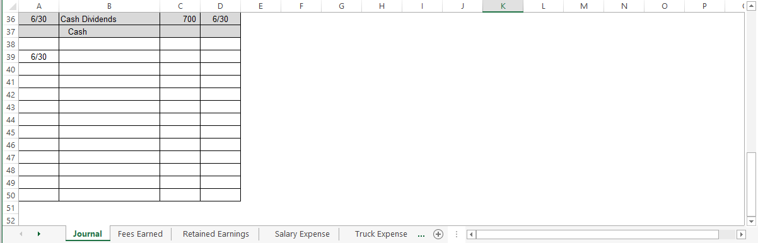

*Sample Student Sheet:* 